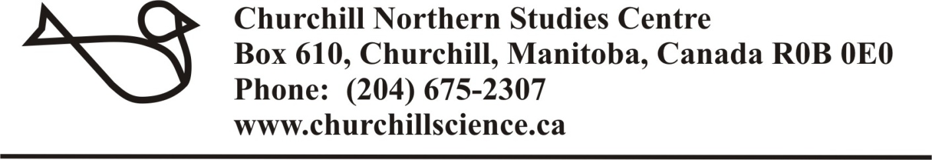
Northern Research Fund 2018 Application for Funding
Please provide all of the following information regarding your project (8 pages maximum):
1.0 Applicant
Name
Institution/Affiliation
Mailing Address
Phone | Fax
Email
Position
Postdoctoral Fellow Ph.D student M.A./M.Sc. student Undergraduate thesis student
Name(s) and Supervisor(s)
Institution/Affililation

2.0 Co-applicant of field assistant information (where applicable)
Name
Institution/Affiliation
Mailing Address
Phone | Fax
Email

3.0 Title of the project (maximum 100 characters)

4.0 Executive summary (maximum 300 words in plain language to be used for the general public)

5.0 Time frame for research the project (2018-2019)
Anticipated time frame and duration of project (e.g., a two year project, to be initiated in 2018)
Estimated start date of field research | Estimated completion date of field research

6.0 Number of personnel in field research team (used for CNSC planning purposes)
Total number of expected field team members

7.0 Project details (Provide a summary that conveys the objectives and relevance of the proposal research with references, maximum 1000 words

8.0 Budget: (Provide complete budget information using the following table. Please indicate where NRF funds will be utilized to offset costs. In the space below the table, please include a brief explanation and justification for your total budgeted expenditures.)
Proposed Expenditures | Budgeted Cost | NFR Request Amount
Salaries, benefits, and stipends |  | Not Eligible
Equipment |  | Not Eligible
Materials and supplies |  | Not Eligible
Travel (Max NRF request = 1 rail or 1 air)
Field Accommodation (1 user day = $73.50/day)
Vehicle rentals and fuel (1 vehicle day =
Dissemination costs |  | Not Eligible
Other (please specify) |  | Not Eligible
Total

9.0 Northern Research Fund request for support
Type of Funding | Total amount to be used in 2018 | Amount requested from NRF *
9.1 User days (CNSC accommodation and meals. Total user days = # of user days x # of people.)
9.2 Vehicle days
Please indicate type of vehicle: pickup truck, suburban, van, ATV, snow machine
9.3 Travel voucher
(Winnipeg to Churchill return only)
Please indicate air or rail. Maximum of 1 voucher request total.
* Applicants may apply for any level of support from among the types of funding that are available to a maximum of 50% of the expected budget. For example, if the project is expected to require 20-user days and 8 vehicle days, then an applicant can apply to the NRF for up to 10 user-days and 4 vehicle days.

10.0 Research Support (List all sources of support held as an applicant or co-applicant in the past five years including support applied for. Include the 1) title of each proposal, 2) source of funding, 3) amount of award, 4) duration of award.)

10.1 Previous NRF awards (Indicate the year and level of support received in your previous competitions)

11.0 Contributions to Research (The five (5) most significant and referred publications and/or non refereed papers, conference or public presentations, books or book chapters and reports made over the past five years. In addition, please identify publications with previous NRF-support. Note to students: public presentations, guest lectures, and communications count! Please carefully consider this section and provide information.)

12.0 Research permits and licenses
List all permits required for this project and the status for applications still pending. It is the responsibility of the researcher conducting research at the CNSC to obtain all necessary permits prior to arrival at the CNSC and to provide copies of these permits to the CNSC.
Permits required for research and status of permits
Do you have WHIMIS training for all field party members who will be staying at the CNSC?

Yes No

Do you have a valid Possession and Acquisition License (PAL) to carry a firearm in Canada?

Yes No

Will you be applying for a Non-Resident Temporary Borrowing Permit for firearms in Canada?

Yes No

13.0 Special calls: If you wish to be considered for any special calls specified for 2018, please specify which below and include a brief statement including how any financial assistance may assist graduate students on the project.
Please consider me for the following special calls:

Please complete the above form and forward no later than January 12, 2018 to:
Email: research@churchillscience.ca

If you have any questions, please contact Dr. LeeAnn Fishback, Scientific Coordinator for assistance.
research@churchillscience.ca

Terms of Northern Research Fund award
Upon notification of successfully obtaining a Northern Research Fund award, the recipient will be required to agree to the following conditions:

1) The award must be utilized during the CNSC 2018 fiscal year (1 April 2018 and 31 March 2019).

2) Applicants are required to notify the Scientific Coordinator in writing of any portion of the allocated award (cash or in-kind services) that they are unable to utilize. Researchers will be billed for the value of any unused portion of their NRF grant they fail to return. Unused NRF awards, either in part or in whole, will revert to the CNSC. The Executive Director and Scientific Coordinator, in consultation with the Chair of the Research and Education Committee, may distribute unused portions of the NRF to other currently funded projects with a demonstrable need for additional support.

3) Cash award recipients will be required to remit to the CNSC, by 31 March 2019 original invoices and receipts for all purchases of goods and services related to their research projects, to the amount of the value of the cash award.

4) A summary report of the research project activities must be submitted to the CNSC by 31 March 2019.

5) Successful applicants are expected to acknowledge the NRF in presentations and publications or technical reports resulting from the funded research.

The CNSC appreciates receiving copies of any published papers, reports or theses based on NRF supported research. The Centre also requests that researchers donate research and teaching materials to the CNSC Library. Donations can include copies of unpublished or published research articles, newly published or used books, maps, undergraduate or graduate level poster presentations, course reports, presentation materials related to Churchill and other northern regions, photographs, slides or digitized images, and newsletters and promotional materials relevant to northern research.

